

# 

### Semester Two Examination, 2017

### Question/Answer booklet

# MATHEMATICS

If required by your examination administrator, please place your student identification label in this box

**METHODS**

**UNITS 3 AND 4**

## Section Two:

## Calculator-assumed

|  |  |  |  |  |  |  |  |  |  |  |
| --- | --- | --- | --- | --- | --- | --- | --- | --- | --- | --- |
| Student Number: In figures |  |  |  |  |  |  |  |  |  |  |

In words

Your name

## Time allowed for this section

Reading time before commencing work: ten minutes

Working time: one hundred minutes

## Materials required/recommended for this section

***To be provided by the supervisor***

This Question/Answer booklet

Formula sheet (retained from Section One)

***To be provided by the candidate***

Standard items: pens (blue/black preferred), pencils (including coloured), sharpener, correction fluid/tape, eraser, ruler, highlighters

Special items: drawing instruments, templates, notes on two unfolded sheets of A4 paper, and up to three calculators approved for use in this examination

## Important note to candidates

No other items may be taken into the examination room. It is **your** responsibility to ensure that you do not have any unauthorised material. If you have any unauthorised material with you, hand it to the supervisor **before** reading any further.

## Structure of this paper

|  |  |  |  |  |  |
| --- | --- | --- | --- | --- | --- |
| Section | Number of questions available | Number of questions to be answered | Working  time (minutes) | Marks available | Percentage of examination |
| Section One:  Calculator-free | 8 | 8 | 50 | 52 | 35 |
| Section Two:  Calculator-assumed | 13 | 13 | 100 | 97 | 65 |
|  | | |  | **Total** | 100 |

|  |  |  |
| --- | --- | --- |
| Markers use only | | |
| Question | Maximum | Mark |
| 9 | 8 |  |
| 10 | 7 |  |
| 11 | 8 |  |
| 12 | 7 |  |
| 13 | 9 |  |
| 14 | 8 |  |
| 15 | 8 |  |
| 16 | 7 |  |
| 17 | 8 |  |
| 18 | 7 |  |
| 19 | 8 |  |
| 20 | 6 |  |
| 21 | 6 |  |
| S2 Total | 97 |  |
| S2 Wt (×0.6701) | 65% |  |

## Instructions to candidates

1. The rules for the conduct of examinations are detailed in the school handbook. Sitting this examination implies that you agree to abide by these rules.

2. Write your answers in this Question/Answer booklet.

3. You must be careful to confine your response to the specific question asked and to follow any instructions that are specified to a particular question.

4. Additional working space pages at the end of this Question/Answer booklet are for planning or continuing an answer. If you use these pages, indicate at the original answer, the page number it is planned/continued on and write the question number being planned/continued on the additional working space page.

5. Show all your working clearly. Your working should be in sufficient detail to allow your answers to be checked readily and for marks to be awarded for reasoning. Incorrect answers given without supporting reasoning cannot be allocated any marks. For any question or part question worth more than two marks, valid working or justification is required to receive full marks. If you repeat any question, ensure that you cancel the answer you do not wish to have marked.

6. It is recommended that you do not use pencil, except in diagrams.

7. The Formula sheet is not to be handed in with your Question/Answer booklet.

Section Two: Calculator-assumed 65% (97 Marks)

This section has**thirteen (****13)** questions. Answer **all** questions. Write your answers in the spaces provided.

Working time: 100 minutes.

Question 9 (8 marks)

The graph of $y=f(x)$ is shown below for $0≤x≤2$, where $f\left(x\right)=1+2xe^{1-x}$.

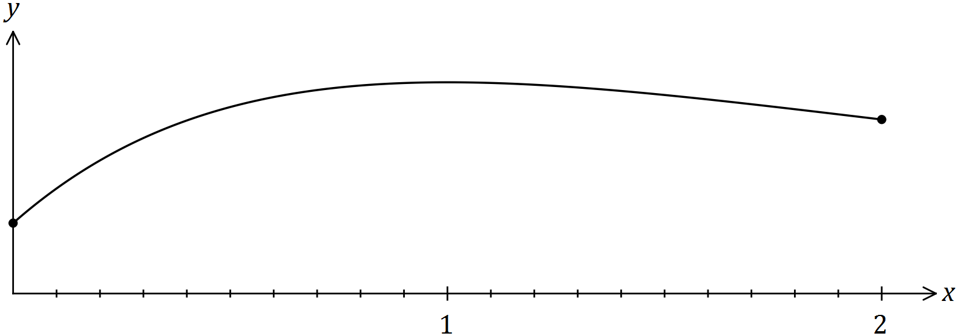

(a) Show that $f(x)$ has a stationary point at $(1, 3)$. (3 marks)

(b) An estimate for the area bounded by the curve, the $x$-axis, the $y$-axis and the line $x=2$ is required. A suitable estimate can be calculated from the sum of the areas of four centred rectangles with heights $f\left(0.25\right), f\left(0.75\right), f\left(1.25\right)$ and $f(1.75)$, each with a width of $0.5$ units.

(i) Clearly show these four rectangles on the graph above. (2 marks)

(ii) Use the rectangles to estimate the area, giving your answer correct to 2 decimal places. (3 marks)

Question 10 (7 marks)

The capacity, $X$ mL, of glass bottles made in a factory can be modelled by a normal distribution with mean $μ$ and standard deviation $3.4$ mL.

(a) If $μ=784$, determine

(i) $P(X≥780)$. (1 mark)

(ii) $P\left(X<786 \right| X>780)$. (2 marks)

(iii) the value of $x$, if $P\left(X≤x\right)=\frac{1}{3}$. (1 mark)

(b) Given that $P\left(X>k\right)=0.937$,

(i) determine the value of $μ$ in terms of $k$. (2 marks)

(ii) determine $μ$ if $k=503$. (1 mark)

Question 11 (8 marks)

From a random survey of 355 users of a free SMS service, it was found that 212 would stop using it if they had to pay.

(a) Based on this survey, calculate the percentage of users who would stop using the service. (1 mark)

(b) Calculate the approximate margin of error for a 95% confidence interval estimate of the proportion of users who would stop using the service. (3 marks)

(c) Determine a 95% confidence interval for the proportion of users who would stop using the service. (2 marks)

(d) If 30 identical surveys were carried out and a 95% confidence interval for the proportion was calculated from each survey, determine the probability that at least 29 of the intervals will contain the true value of the proportion. (2 marks)

Question 12 (7 marks)

The length, $T$ minutes, of phone calls to a help line is a continuous random variable with probability density function given by

$$f\left(t\right)=0.3e^{-0.3t}, 0≤t<∞.$$

(a) Determine the probability that a randomly chosen call lasts less than $6$ minutes. (2 marks)

(b) An operator answers $20$ calls, chosen at random. If call times are independent of each other, determine the probability that at least $4$ of them will exceed $6$ minutes. (2 marks)

(c) An operator has been on a call for exactly $7$ minutes. Determine the probability that the call will end within the next minute. (3 marks)

Question 13 (9 marks)

A fair die has one face numbered 1, three faces numbered 2 and two faces numbered 3.

(a) Determine the probability that the second even number occurs on the fourth throw of the dice. (3 marks)

(b) The die is thrown twice and $X$ is the sum of the two scores.

(i) Complete the table below to show the probability distribution of $X$. (2 marks)

|  |  |  |  |  |  |
| --- | --- | --- | --- | --- | --- |
| $$x$$ | $$2$$ | $$3$$ | $$4$$ | $$5$$ | $$6$$ |
| $$P(X=x)$$ |  | $$\frac{1}{6}$$ | $$\frac{13}{36}$$ | $$\frac{1}{3}$$ |  |

(ii) Determine $P\left(X=5 \right| X≥5)$. (2 marks)

(iii) Calculate $E{(X)}$. (2 marks)

Question 14 (8 marks)

150 black and 850 white spherical beads, identical except for their colour, are placed in a container and thoroughly mixed.

In experiment $A$, a bead is randomly selected, its colour noted and then replaced until a total of 40 beads have been selected.

(a) The random variable $X$ is the number of black beads selected in experiment $A$.

Determine $P(X>9)$. (2 marks)

(b) Experiment $A$ is repeated 20 times. Determine the probability that at least one black bead is selected in each of these experiments. (2 marks)

In experiment $B$, a bead is randomly selected, its colour noted and then replaced until a total of 25 beads have been selected.

Experiments $A$ and $B$ are repeated a large number of times, with the proportions of black beads in each experiment, ${\hat{p}}_{A}$ and ${\hat{p}}_{B}$ respectively, recorded.

(c) The distribution of which proportion, ${\hat{p}}_{A}$ or ${\hat{p}}_{B}$, is most likely to approximate normality? Explain your answer and state the mean and standard deviation of the normal distribution for the proportion you have chosen. (4 marks)

Question 15 (8 marks)

A researcher wants to estimate the proportion of Western Australian teachers who are aged under 30. The researcher plans to collect sample data by visiting schools and asking teachers.

(a) Discuss two different sources of bias that may occur when the researcher collects their sample data and suggest a procedure to avoid bias. (4 marks)

(b) Determine, to the nearest 10, the sample size the researcher should use to ensure that the margin of error of a 95% confidence interval is no more than 3%. (3 marks)

(c) Comment on how your answer to (b) would change if the researcher had a reliable estimate that the population proportion was close to 12%. (1 mark)

Question 16 (7 marks)

The curve $y=5π-x+\sin{x}$ is shown below passing through $P(3π, 2π)$.

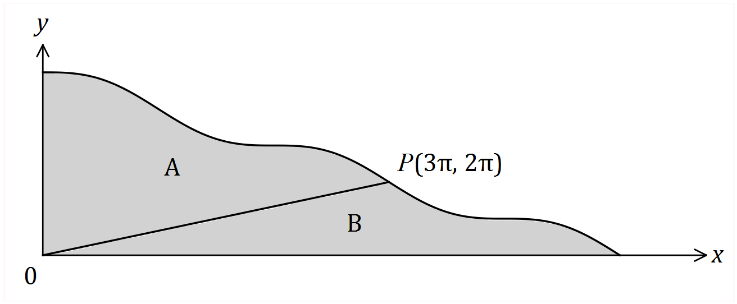

A straight line joins the origin to $P$, dividing the shaded area into two regions, $A$ and $B$.

(a) Show that when $x=5π$, $y=0$. (1 mark)

(b) Determine the value of $\int_{0}^{3π}{\overset{ }{\underset{ }{\left(5π-x+\sin{x}\right)}}}dx$. (2 marks)

(c) Determine the ratio of the area of region $A$ to the area of region $B$ in the form $1:k$.

(4 marks)

Question 17 (8 marks)

Hick's law, shown below, models the average time, $T$ seconds, for a person to make a selection when presented with $n$ equally probable choices.

$T=a+b\log_{2}{(n+1)}$, where $a$ and $b$ are positive constants.

(a) Draw the graph of $T$ vs $n$ on the axes below when $a=4$ and $b=8$. (3 marks)

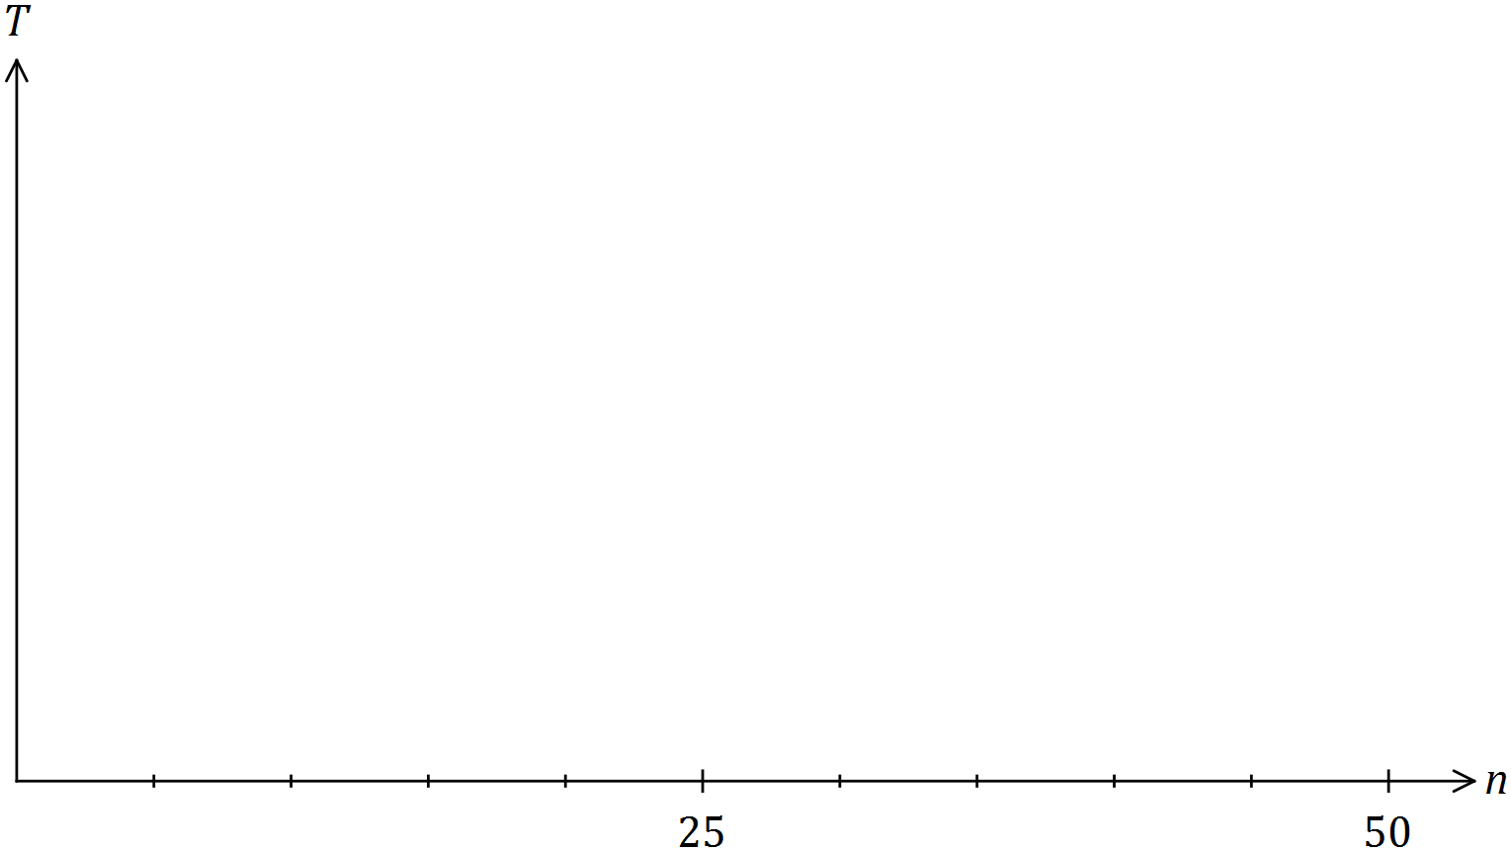

(b) When a pizzeria had 10 choices of pizza, the average time for patrons to make a choice was 40 seconds. After doubling the number of choices, the average time to make their choice increased by 25%.

Modelling the relationship with Hick's law, predict the average time to make a choice if patrons were offered a choice of 35 pizzas. (5 marks)

Question 18 (7 marks)

A polynomial function $f(x)$ is such that $\int_{3}^{7}{\overset{ }{\underset{ }{3f\left(x\right)}}}dx=21 .$

(a) Show that $\int_{7}^{3}{\overset{ }{\underset{ }{f\left(x\right)}}}dx=-7$. (2 marks)

(b) Determine the value of $\int_{3}^{4}{\overset{ }{\underset{ }{\left(f\left(x\right)+3\right)}}}dx+\int_{4}^{7}{\overset{ }{\underset{ }{\left(3+2x+f\left(x\right) \right)}}}dx$. (5 marks)

Question 19 (8 marks)

The mass, $X$ g, of wasted metal when a cast is made is a random variable with probability density function given by

$$f\left(x\right)=\left\{\begin{matrix}\frac{2x}{a^{2}} & 0≤x≤a, \\ & \\ 0 & \text{elsewhere},\end{matrix}\right.$$

where $a$ is a positive constant.

(a) Determine $E{(X)}$ in terms of $a$. (2 marks)

(b) The total mass of wasted metal from a random sample of 40 casts was 960 g. Estimate the value of $a$. (2 marks)

(c) If $a=12$, determine

(i) $P(X≥4)$. (1 mark)

(ii) $\operatorname{Var}{(X)}$. (3 marks)

Question 20 (6 marks)

A random sample of 460 koalas from a nature reserve are captured, tagged and then set free. After a suitable interval, during which time it is assumed that the koala population does not change, another random sample of 280 koalas is caught and 14 of these are observed to be tagged.

(a) Show that a point estimate for the size of the koala population is 9 200. (1 mark)

(b) Construct a 98% confidence interval for the proportion of koalas in the population that are tagged. (2 marks)

(c) Deduce an approximate 98% confidence interval for the number of koalas in the reserve.

(3 marks)

Question 21 (6 marks)

A popcorn container of capacity $275$ mL is made from paper and has the shape of an open inverted cone of radius $r$ and height $h$.

Determine the least area of paper required to make the container. (6 marks)

Additional working space

Question number: _________

Additional working space

Question number: _________

Additional working space

Question number: _________

Additional working space

Question number: _________

© 2017 WA Exam Papers. Kennedy Baptist College has a non-exclusive licence to copy and communicate this document for non-commercial, educational use within the school. No other copying, communication or use is permitted without the express written permission of WA Exam Papers. SN245-105-3.